**New York City Motor Vehicle Collisions**

**Data Source**

The Data for this Project was taken from <https://data.cityofnewyork.us/Public-Safety/NYPD-Motor-Vehicle-Collisions/h9gi-nx95>.

Data Source Provided by: NYPD

**Data Normalization**

The Data obtained was not normalized and needed to be normalized before analysis.

Following steps were taken to normalize the data.

1. Duplicate Values were removed.
2. Multiple Causes of Accidents were divided into broader categories.
3. Multiple Vehicle types were divided into broader categories.

**Data Visualization**

While visualizing the data I focused on finding trends and data distribution to find solutions to following four problem statements.

1. What is the distribution of Cyclists, Motorists and Pedestrians affected in motor vehicle collision per Borough?
2. Major Causes for accidents and their distribution in different Boroughs.
3. Most dangerous zip codes of NYC based on motor collisions in the past 5 years.
4. Accident trend based on Month and Time.

**Conclusions**

1. Most number of victims of motor collisions is recorded in Brooklyn.
2. Most number of accident related victims are recorded in Brooklyn with area zip code as 11236 in the past 5 years but in 2017 it was 11207.
3. Major Cause for Motor Collisions in NYC is Driver Inattention/Distraction apart from “unspecified cause”.
4. February has always seen a dip in the number of accidents.
5. Most number of accidents recorded is between 3 to 6 pm.

**Next Steps**

1. Deeper dive into time frame in accordance to causes.
2. Dynamic usage of Tableau parameters to give user more interactivity.

**Dashboards**

1) New York City Motor Vehicle Collision ( Filter Capability : Year )

* Distribution per Borough : Stats per borough
* Zip Code Trend : Color codes the stats/zip code
* Monthly Distribution : Enables trend view for all as well as individual borough selection

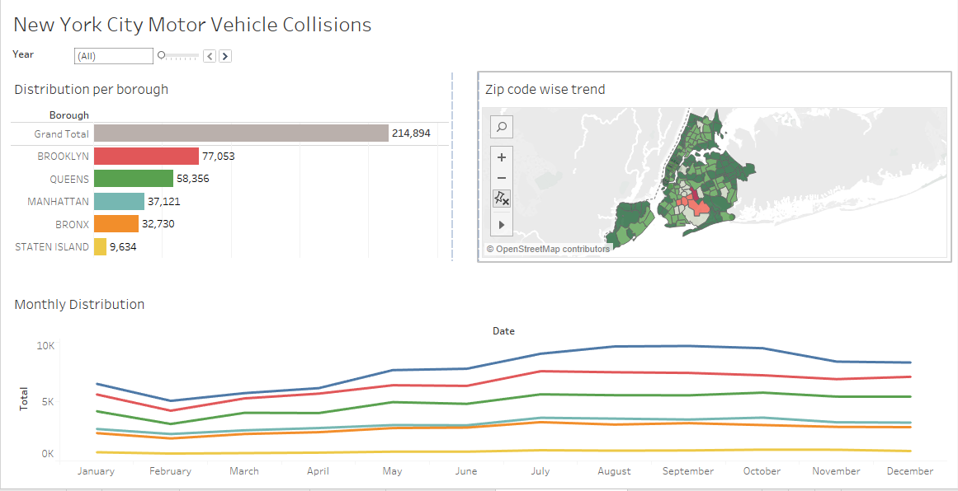

The image below shows the dynamic capabilites of the dashboard to view particular borough stats and dive deeper for a detailed level.

**Dynamic filter: This selection navigates to the detailed dashboard**

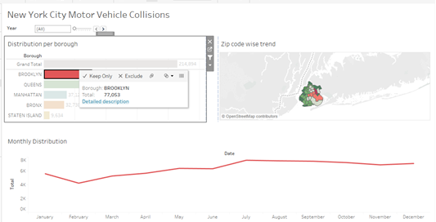

2) Detailed Borough Status ( Filter Capability : Weekday )

* Distribution Borough Stats : Breaks down the stats per type
* Day wise Distribution : Shows daily trend and has filter capabality to dive into a particular day to see hourly trend
* Major Cause of Accident : Gives the Contributing factor stats per borough as per selection from the Main Dashboard ( High Level )

